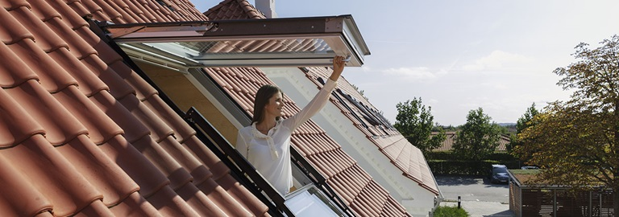

Group Members

Tristan Rottevig Møller, 201706862  
Mads Vikær Lund, 201504445  
Hillal Hamdan, 202010801  
Anisa Mohamed Hassan, 201709369

Group 21

WiNdow Blinds for the Future

Handout 1 – Case 29

Content

1 Part 1 – Collect knowledge 2

1.1 Investigating problem domain 2

1.2 Why-Why-Why 3

1.3 Fishbone 4

1.4 Forcefield 4

1.5 Triz Nine windows 5

1.6 Customers Analysis 6

1.7 Findings 7

2 Part 2 – Find paralysis rings 8

3 Part 3 – Create insight 11

4 Part 4 - Innovation Task 13

4.1 The final innovation task: 13

5 References 15

Appendix – A1 16

Appendix - A2 18

# Part 1 – Collect knowledge

In this course we will collaborate with VELUX to develop innovative window blind. The VELUX story began in 1941 with the founder Villum Kann Rasmussen’s simple idea of transforming unused dark attics into bright livable spaces filled with daylight and fresh air (VELUX Group, 2021). Their key products are roof windows, flat roof skylights and modular skylights for commercial buildings as well as accessories like blinds, roller shutters and sensor-driven remotes to control it all. Their products help create a bright and energy-efficient indoor climate in which to live, work and play. All their products can be seen on their website.

The precondition for this case is that the product creates free access to light, air, heat, and view, but in certain situations some or all of these traits are undesirable. Our task is to develop window blinds (e.g. shutters) to control light, temperature, and privacy through an electrical roof window. The task definition is open, i.e. there are few predefined requirements. However, there are some closed tasks in terms of the positioning of the heat and light control – based on heat reduction and other technical aspects. Figure 1 shows an example of where the heat and light control could be placed.

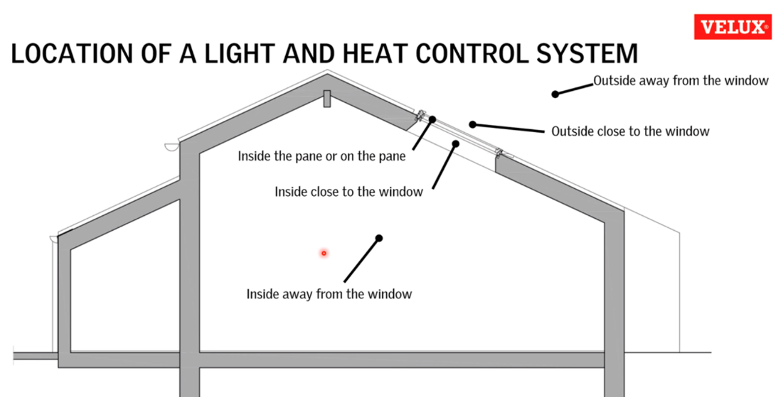

Figure 1 - 'Closed task' in relation to placement/location of heat control.

## Investigating problem domain

The problem definition was only a single statement and more information was needed, which led us to our initial research. Here we looked at the industry – what products are available and what new technologies and concepts are being developed. In order to develop something useful for VELUX, we had to get acquainted with what they do, how they do it and what their turnover looks like. A meeting was then setup with VELUX (16/03/21), where this collected knowledge was used to ask well rounded questions. A resumé and interview questions can be found in appendix A1.

The meeting with the company representatives gave us a deeper insight of the case and which potential areas that could be challenged. The following techniques will be used to investigate the problem domain.

* Why-Why-Why
* Fishbone
* FORCE-FIELD
* Triz Nine windows
* Customers Analysis

## Why-Why-Why

The Why-Why Diagram helps to identify the root causes of a problem by narrowing down and eliminating possible causes, ideally to one or more addressable root causes (Visual Paradigm, 2021). The statement of work provided by VELUX states:

*‘How to control light, temperature, and privacy through an electrical roof window in the future.’*, (VELUX, 2021)

The case description does not directly state the company’s issue with their current products/organizational setup. Creating a new product for the future is not an issue, it is therefore necessary to frame the question differently. The definition of innovation *‘is the practical implementation of ideas that result in the introduction of new goods or services or improvement in offering goods or services’* (Wikipedia, 2021), hence it could be interesting to change the question to understand missing features on current products. This includes products provided by VELUX but also the entire industry. This is also good exercise to identify different technologies within the field of window blinds.

The original case description is rephrased into the following problem statement:

*‘Standard roof window blinds are insufficient’*

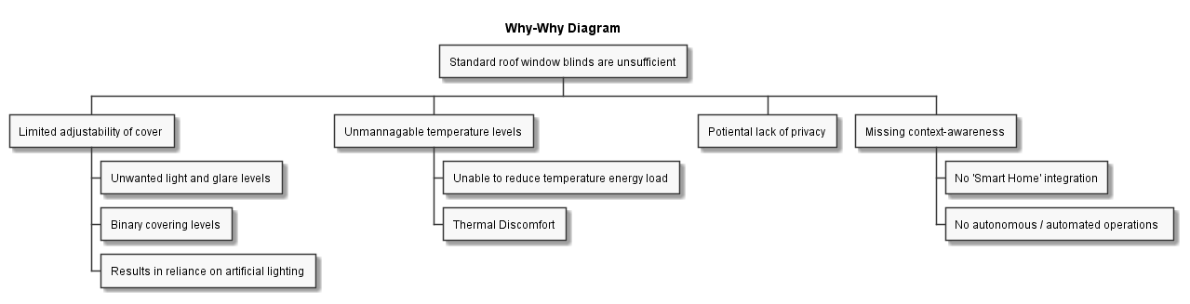

Figure 2 - Why-Why diagram. The root is the problem statement, where new causes are recursively identified each level by asking ‘Why’.

There are different ways one could have rephrased the original case description. By changing the focus on missing features on existing products, it should be possible to identify ‘root causes’ for said products – with that said it does narrow the perspective on ‘absent’ capabilities, whereas this might not be the case. It could be that inexpensive, resistant and flexible roof windows will be a future disruptive technology (a witty example could be a roof window using sand as a covering method, see (Kod, 2021)). However, it is a great tool to start identifying possible causes and challenge existing solution. Figure 2 shows the Why-Why diagram, where the problem statement is the ‘root’ of the tree.

## Fishbone

The “FishBone” diagram identifies possible causes of a problem and helps ideas into useful categories. The initial problem definition in the Fishbone is to determine an innovative product for VELUX. This technique identified several leading causes including **place**, **personal needs**, **environment**, and **social aspects**. The FishBone method will narrow down all the unknowns and focus on the root causes while taking into consideration the other aspects. Figure 3 depicts the personal needs and the special characteristics as a closed area, which is a potential of the nature of the problem and is not to change. The other causes were identified as open areas and subject to change.

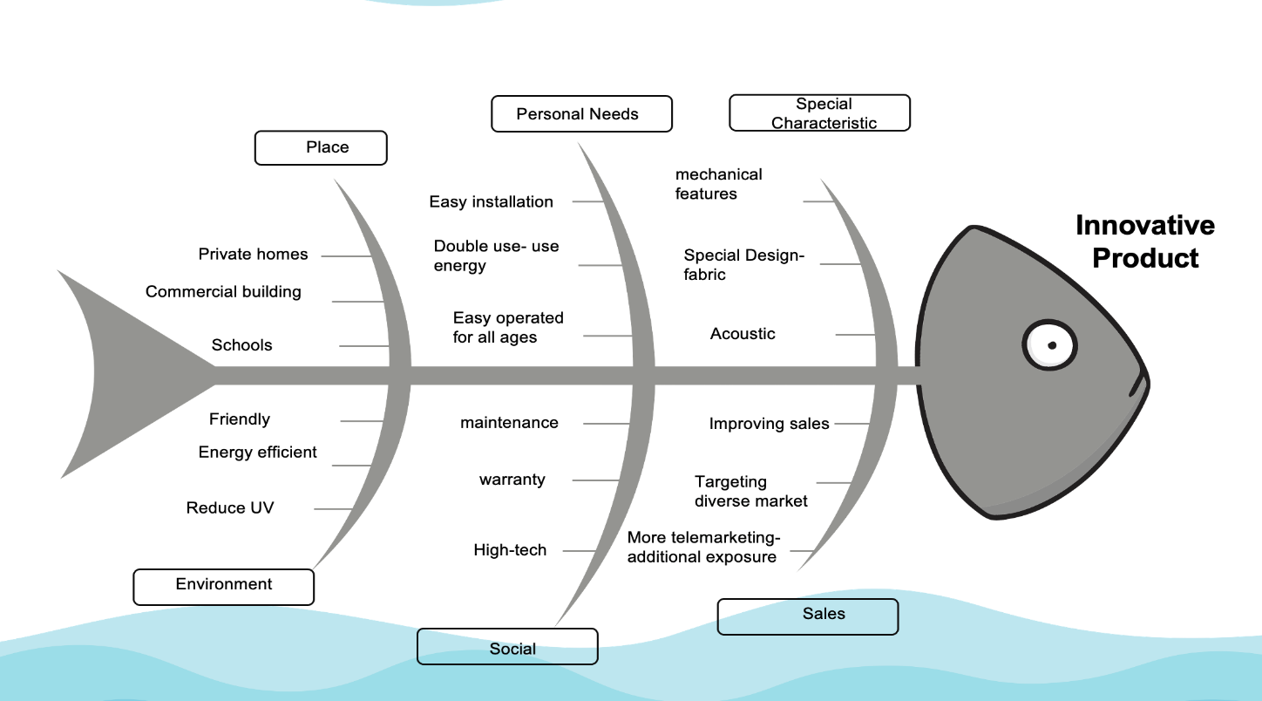

Figure - FishBone diagram

## Forcefield

The Force Field analysis involves creating potential pros and cons around a specific case according to (Emerald WORKS, 2021). It is used to gather more knowledge which leads to choosing whether to continue with the research. VELUX wants to develop the idea of window blinds for the future. The case is very open and does not involve any possible solutions in which they want to investigate or innovate on.

Figure 4 illustrates pros and cons for the case of developing a window blind for the future.

The Force Field analysis shows that the total score of the pros are higher than the cons which leads us to think that it can be beneficial for the company to continue with the research. The force field analysis can be used later in the process to investigate more specific ways to solve the case. VELUX as a company has several new ideas on how to innovate window blinds. Many of these ideas need to be sorted and considered from several points of view. For example, cost, public interest, or success rate. With the Force Field analysis these parameters can be defined and compared. With the use of this “fast” method every decision in the project can be made from a greater bases of decision - a project or several can be chosen to further investigate with other more complicated methods.

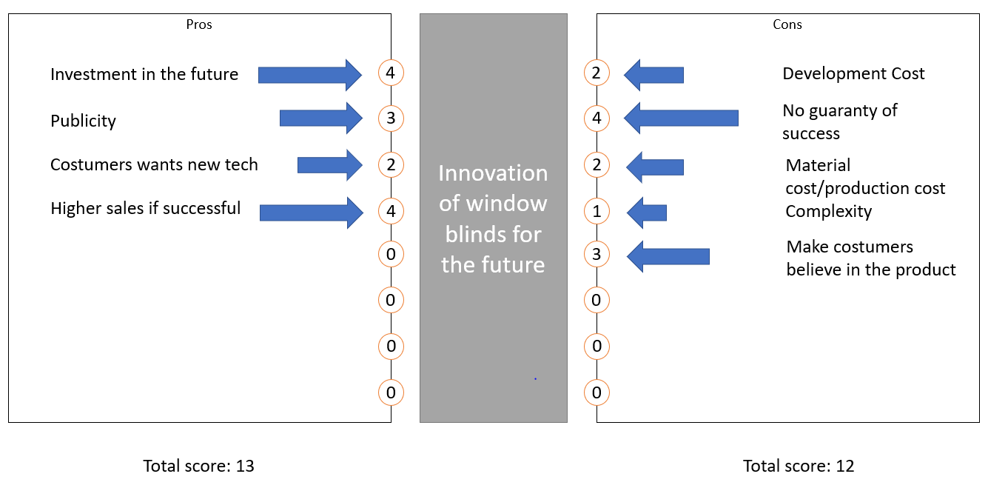

Figure - Force field analysis

## Triz Nine windows

This approach is the overview of the TRIZ problems solving process. It is a distinctive feature of TRIZ, distinguishing it from other conventional problem-solving methods (e.g. brainstorming) that attempt to find specific factual solutions to factual problems directly. As stated in Figure 5, there are several root causes that need to be elaborated to find out from VELUX their future plans

Figure - Triz Nine Windows

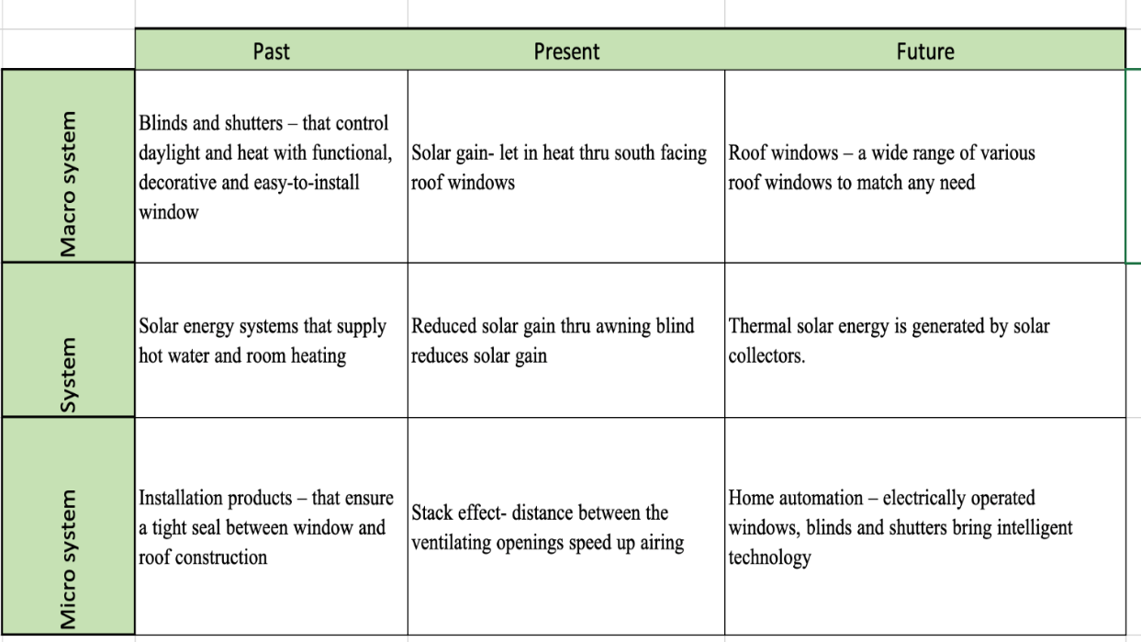

## Customers Analysis

The Discover phase is the first phase in **Double Diamond** and is characterized by divergent thinking (see Appendix A2). Here the team explores the needs, problems, and opportunities by doing **research** and **analysis** of user needs, market data, trends, and other information. The first phase **Design Thinking** is **Empathize**, where the goal is similarly to understand and research the user needs.

VELUX states that their main customer segment is houseowners with the financial means to purchase electronic roof windows. Since the window blinds in this project are accessories to the roof windows, the customer needs should be in regard to the window as whole including both the blind and the window.

A way to look at the customer needs is to look at the pains and gains and form a *value proposition* canvas. **Value proposition canvas** is formed around two building blocks – **customer profile** and a **company’s value proposition.**

**Customer Profile:**

* **Gains**: the benefits which the customer expects and needs, what would delight customers and the things which may increase likelihood of adopting a value proposition.
  + A good night sleep, without waking up to the sun in your face
  + Save money on electrical bill for light
  + Fit your personal interior color palette.
  + Partly control the temperature in the room, without the use of a heater.
  + Control all features from you bed
  + Preserve the view
* **Pains**: the negative experiences, emotions, and risks that the customer experiences in the process of getting the job done.
  + Needs to be mounted to the specific electronic window
  + Cost a bit more than normal ‘everyday’ blinds
  + The control needs batteries
  + Block-out removes the option to ventilate.
* **Customer jobs**: the functional, social and emotional tasks customers are trying to perform, problems they are trying to solve and needs they wish to satisfy.
  + Sleep
  + Partly control the temperature and lighting in the room.

**Value Map**

* **Gain creators**: how the product or service creates customer gains and how it offers added value to the customer.
  + Darkens the room completely
  + The user controls the amount of light in the room
  + Come in a variation of colors.
  + Has an insulating effect
  + Has a remote control without cords.
  + One-way mirror effect.
  + Easy to clean
* **Pain relievers**: a description of exactly how the product or service alleviates customer pains.
  + Simple installation with manual
  + Good quality with 3-year warranty
* **Products and services:** the products and services which create gain and relieve pain, and which underpin the creation of value for the customer.
  + Home delivery
  + Installation done by a professional
  + Right to withdrawal up till 14 days
  + Call sales company and customer service
  + Visit sales company and their showroom

Many of these needs can be met by simple curtains, but customers who buy from VELUX are often people who have the surplus for it. It is people who buy for delight and not necessity or price.

## Findings

The different methods have been used to shed light on the problem domain from a technological perspective, but also identify potential user needs. There are three areas that should be challenged:

1. Existing technological capabilities, are they valid or are there other potential technologies that should be considered?
2. VELUX’s current market and lead customers, have they disregarded potential customers because of product catalog?
3. Reduction of environmental waste and product sustainability.

The *value proposition canvas* revealed user needs (based on superficial research; user workshops or similar tools should confirm assumptions and find explicit and implicit needs). The needs can be summed up as a balance between cost and capabilities. The next section will attempt to challenge some of these aspects.

# Part 2 – Find paralysis rings

A critical part of innovation is challenging existing products and technologies, i.e. ‘what is’. It is important to emphasize that it is not an attack or criticism, but a method to explore the domain and perhaps identify new areas that have not yet been explored. The tools used in the previous sections have helped to identify and explore the company’s market and technology domain.

In this section we take a deeper look into the actual products and start a challenging process by using the ‘WHY A-B-C”-method introduced by Dr. Edward de Bono (Leka, 2021). VELUX have already held previous sessions where they applauded students to challenge the idea of window blinds, see (VELUX Group, 2021).

The challenging process should result in a plausible strategic and technological foresight, i.e. opportunities.

**WHY – Alternatives/Uniqueness**

The case description requests ideas about future capabilities for roof windows. Our approach is now to challenge the very idea of a roof window – some questions may seem absurd, but sometimes other-worldly questions start discussions that result in new ideas.

1. Why do you only use natural light to generate lighting?
2. Why do you use glass windows?
3. Why use fabric to cover windows – have you tried other methods?
   1. Gas that changes structure based on regulation techniques.
   2. Can we block light with light – absorb/block light photons?
4. Why is the window in a static frame (could it somehow be dynamic with gradual transition)?
5. Why do you provide roof windows with autonomous/automated properties?
6. Why develop new solutions when the current one’s work?
7. Why use own connection/wireless devices and not integrate with 3rd party applications (Apple Homekit etc)?

**Why – Because/Reason**

It is now worth looking into the reasoning for the current capabilities. Most reasons are very valid and based on extensive research, nonetheless it must be challenged! The list below can be seen as answers to the previous questions. The reasoning is based on answers from VELUX and own research.

1. Because it does not require a specific device to produce. Natural light also increases serotonin and D-vitamin levels.
   1. *Would it be possible to generate artificial light that ‘mimics’ natural lighting?*
2. Cheap material can convey light without losing properties.
   1. *Are there other materials that may be cheaper and still be able to convey light or enhance it?*
3. Fabric is often a cheap alternative and can be changed to meet personal needs without changing the structure/architecture of the window.
4. It creates stability and allows to hold the glass window and blinds etc.
5. There is a user demand and it is a general tendency in the industry.
6. There is a rising demand due to competition.
7. Never got answer – perhaps because ‘partnership/collaboration’ fees.

**Why – Cut/Necessity**

Looking at the necessity of a product’s aspect is often the ‘easiest’ task to start with, i.e. ‘do we need this at all’?

1. Do we need to use fabric blinds to cover windows?
2. Do we need to use mechanical parts or software to make windows autonomous/automated?
3. Do we need roof windows? Would side windows suffice?

The ABC challenge analysis has pointed out potential ‘redundancies’ or blind spots in VELUX’s existing products. The analysis has been product orientated, but by looking deeper into the reasons behind VELUX’s product catalog, we might be able to find new potential markets, e.g. ‘the product catalog is heavily biased, only high quality, complicated and mechanical window blinds are present, whereas the latent need for users are durable, autonomous and cheap window blinds’. This is of course speculation and requires extensive research on user needs, explicit and implicit.

As mentioned, the ABC analysis was mostly directed at VELUX’s own product catalog. Some of the aspects of the products that were challenged might already be implemented or found in existing products. Innovation is rarely completely new revolutionary services; it is often based on previous (failed or successful) products/ideas. Table 1 shows a comparison matrix of different high-end products.

Table 1 - Comparison matrix between products. A = Full Support, B = Partial Support, Limited/Barely Support, X = Unknown

|  |  |  |  |  |  |
| --- | --- | --- | --- | --- | --- |
| Product | Customizable | Design | Price | Pervasive/  SmartHome | Uniqueness |
| SAGEGLASS  (Saint-Gobain, 2021) | A | A | C | B | Electrochromic glass, changes structure based on voltage applied. |
| MOTIONBLINDS  (Coulisse, 2021) | A | B | C | A | Full Smart Home integration, uses ‘disruptive’ Thread protocol supported by Amazon, Google and Apple. |
| VELUX | B | A | B | B | Energy efficient, practical, and high-quality skylights. |

The comparison matrix only consists of ‘high-end’ products, however there are two qualities that shines through: Electrochromic glass and a standardized communication protocol (Thread (Wikipedia, 2021)). SAGEGLASS does not use windows blinds to block the sun, it applies different levels of voltage to change the tint of the glass – this shows that there are alternatives to fabric windows covers!

Another element is MOTIONBLINDS’ ‘universal’ integration with Smart Homes. The idea of ubiquitous and pervasive devices was already discussed in the late eighties by Mark Weiser (Weiser, 1991), and a standardized protocol might be a revolutionary idea within this idea of a ubiquitous Smart Home (if there is a demand it might become a disruptive technology). This would allow all technological devices to be integrated into a single ‘hub’ and communicate with each other.

VELUX also mentioned that previously their customers have not requested autonomous technology, however there is a growing demand for these capabilities as new young ‘tech-aware’ homeowners is a growing segment and will definitely by a dealbreaker in the future (Appendix A1).

*“We are the first on in our industry …integrating smart homes into the future, which will disrupt our industry”* - Christian Roetgering, CEO of Coulisse.

There is a lot of talk about pervasive computing, autonomous and automated devices, but is there an actual demand for such products? An article published in 2019 showed that autonomous window blinds had a negative effect in a business environment (Nicola Lolli, 2021). People reported an increase in discomfort in an environment with automated window blinds and ceiling lights. It is therefore crucial that appropriate tools are used to analyze the market and the lead users.

# Part 3 – Create insight

The process of identifying a Lead User involves money and time from the company and the project group who needs to innovate on a current product or product line.

A lead user is defined as a user who find it interesting to innovate and have the skills to do so according to (Lüthje & Herstatt, 2004). A lead user could both be a specific person or a group of people, who wants to get involved in the development process. Lead users can provide valuable insight in relation to potential future products.

The process of a development with lead users can be described in 4 steps:

**Step 1: Start of the Lead User**

* Identify the area which needs to be researched for new possible ideas. The process could be from a cost, design, manufacturing or a fourth point of view.
* Define the goals of the research
  + For example, cheaper manufacturing cost

**Step 2: Identification of Needs and Trends**

* Gather research about the topic and interview experts within the different areas
  + Envolve experts from different fields. For example, gather information about group dynamics, personas and so forth

**Step 3 Identification of the Lead Users**

* Identification of the lead user.
  + Gather questionnaire from product reviews and look for trends and complaints about the specific problem. Contact people who seems to involve themselves in the area which they find irritating. A good example for potential lead users is people who have found ways to solve the problem by themselves but still explain the way and reason for the development.
* Interview potential lead users to gather information about their background. Gather information about them or people they know who would be of use in this innovation process

**Step 4: Concept design**

* Create workshops for the lead users for them to explain their ideas.
* Involve them in the process of development and show production techniques
* Use knowledge about groups dynamics and personas to challenge the ideas and use the push the lead users

**How to find potential lead users for VELUX in the development of window blinds for the future:**

A lead user for VELUX needs to have a technical experience to understand the construction and use of a window blind. Lead users could for example be an engineer, dealer, designer, architect, installer, or carpenter. The installer expects quality, safety, and simple installation. The architect is interested in design, energy balance and technical details. Finally, the dealer will be preoccupied with issues such as logistics, compatibility, and an easy transition from the old to the new products.

One should investigate how VELUX get feedback from the customers who use their products or the carpenter who installs the product. Via this feedback potential lead users can be identified. Combine this information with market data for what future market trends could be to make sure the lead users can identify possible user needs. These needs must be wide so that a large group of customers could see the potential in finding a solution to a specific problem.

VELUX say they do not operate with the term Lead Users. They use marketing data and sales data to predict future trends of the market. The data in which they already have could be used to find potential lead users.

# Part 4 - Innovation Task

There are several aspects of the problem domain that have become apparent by utilizing the different tools described in the previous sections. Some are related to product capabilities, i.e. light and heat control as a function of placement (see Figure 1) or product dilemmas discovered in the why-why diagram (block-out and ventilation).

It is also clear that there is a growing tendency in demand for electrical, autonomous, and automated properties in all devices – it was apparent in own research but also mentioned by VELUX employees (See appendix A1). It would make sense to utilize a protocol that can be integrated with other 3rd party devices and applications. Self-actualization is a key factor in VELUX’s products, their products are, according to themselves, the best on the market and have the highest quality. It provides heat control, ventilation – an overall improvement to indoor climate. However, this is not enough anymore. Figure 6 shows the Kano model that illustrates levels of satisfaction a feature can give. 20 years ago, the previous mentioned features were ‘excitement needs’, but might only be performance or basic needs. The emerging tech-savvy homeowner segment should therefore be included in the innovation task (however not limited to that specific segment).

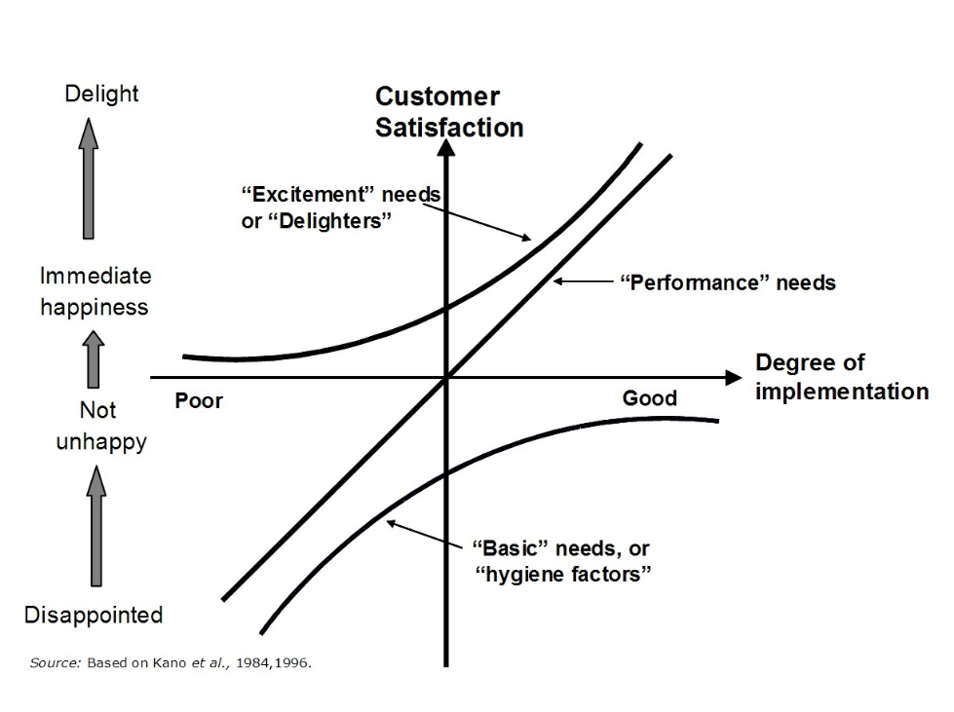

Figure 6 - Customer Satisfaction – Kano Feature Model. (R&D TODAY, 2018)

VELUX as a company focus on safety and sustainability in their products (VELUX Group, 2021). Their product segment of windows uses materials which are very reusable as wood and glass which makes the process of sustainability easier. Some focus points could lie with the use of plastics or energy consumption in the production of the windows. VELUX has initiated a green incentive which should be reflected in the final product/innovation task.

## The final innovation task:

There are three major aspects that should be challenged: sustainability, Smart Home integration and livability. The future model should address them as a holistic solution. The ultimate objective of future construction is three-fold. It should ensure that the energy consumed in the construction and subsequent use of a building is considered in the design phase; it should employ modern technology and visionary design to create an efficient building envelope without compromising the highest standards of comfort and health; and it should have the lowest possible impact on the climate by using renewable energy sources and adopting the concept of climate payback.

*What this could be we have yet to define…*

# References

Coulisse. (2021, 03 13). *A Gamechanger in the market*. Retrieved from Coulisse: https://coulisse.com/blogs/a-gamechanger-in-the-market

Emerald WORKS. (2021). *Force Field Analysis - Analyzing the Pressures For and Against Change*. Retrieved from Mindtools: https://www.mindtools.com/pages/article/newTED_06.htm

Kod, R. (2021, 03 10). *Sand Curtain*. Retrieved from YouTube: https://www.youtube.com/watch?v=VbYXxL60dIA

Leka, S. (2021, 03 10). Company Meeting Preperations. *Module_6_AIE 2021_SL*, 7. Aarhus University.

Lüthje, C., & Herstatt, C. (2004). The Lead User method: an outline of empirical findings and issues for. *R&D Management*, 553-568.

Nicola Lolli, A. N. (2021, 03 13). *Automatic vs Manual Control Strategy for Window Blinds and Ceiling Lights: Consequences to Perceived Visual and Thermal Discomfort*. Retrieved from Solarlits: 2021

R&D TODAY. (2018, 07 22). *IMPROVING PRODUCT FEATURES: WHEN IS MORE LESS?* Retrieved from R&D TODAY: https://www.rndtoday.co.uk/tool/improving-product-features-when-is-more-less/

Saint-Gobain. (2021, 03 13). *WHAT IS ELECTROCHROMIC GLASS?* Retrieved from SageGlass: https://www.sageglass.com/en/article/what-electrochromic-glass

VELUX. (2021, 10 03). *VELUX Innovation Case*. Retrieved from Applied Innovation in Engineering: https://easycountdata.com/InnovationStudent/Cases/CaseInfo/29

VELUX Group. (2021, 03 10). *About the VELUX Group*. Retrieved from VELUX: https://www.velux.com/who-we-are/about-us

VELUX Group. (2021, 03 17). *Sustainability is the way we do business*. Retrieved from VELUX.

VELUX Group. (2021, 03 10). *VELUX International Design Award*. Retrieved from YouTube: https://www.youtube.com/watch?v=sYrJJrVhHdM&t=478s

Visual Paradigm. (2021, 10 03). *Root Cause Analysis Using Why-Why Diagram*. Retrieved from Visual Paradigm Online: https://online.visual-paradigm.com/knowledge/problem-solving/why-why-diagram-for-root-cause-analysis/

Weiser, M. (1991). *The Computer for the 21st Century .* Scientific American.

Wikipedia. (2021, 03 10). *Innovation*. Retrieved from Wikipedia: https://en.wikipedia.org/wiki/Innovation

Wikipedia. (2021, 13 03). *Thread (network protocol)*. Retrieved from Wikipedia: https://en.wikipedia.org/wiki/Thread_(network_protocol)

# Appendix – A1

1. Group meeting on 16-03-2021
   1. Notice of meeting:

Date: 16-03-2021

Time: 12:45

Location: Teams

Participants: Group 21 and 55

Referent: XXX

Agenda:

1. VELUX Group
2. Advanced Material Technology (VELUX)
3. Overview – case study
4. Student Questions
5. Feedback

201707020

* 1. Summary:
  2. VELUX
     + Provide lighting and atmosphere.
     + * Remember to ask for slides afterwards.
     + Sun tunnel = Project light from *another* window – could be light from the roof projected into the living room (could be on another floor)
     + The main business: Roof Windows (Volume, Turnover).
     + Blinds can both be installed on new products but also old windows (add-on).
     + A lot the revenue is donated to science and facilities (e.g. Aarhus University).
     + The focus on providing clean air, sunlight, indoor climate, and environmental care.
     + The focus on sustainability, ‘how may we save the planet’.
     + Dedicated innovation center / teams for developing new products.
     + Front end innovation department → Looks 5-10 years ahead, bringing new concepts.
     + Why buy VELUX?
       - Quality, World-Wide (VELUX adapts product based on geolocation).
         * E.g. ‘Californian’-style skylight for customers on the west coast.
  3. AMT
     + Bunch of nerds from different backgrounds (Nanoengineering, physics…)
     + Scout and research new material technology explore potential opportunities.
     + Ensure that new materials are approved/quality from suppliers.
     + Production sites around the world.
     + Focuses on sustainability (how does material affect carbon footprint)
     + Glass alternatives = Standard glass, plastic, transparent wood
       - Look at carbon-footprint, does the glass have negative effects on frame etc.

*** Delivery to VELUX

* Please delivery the final report to VELUX in May/June, whenever we are done.
* They would like to have us fill out One Pager, 2 min pitch video – see slides from meeting.
* Overview – Case Study.
  + Should it be installable on ‘old windows’?
  + See slides for why. (Update Why-Why diagram?)
  + How would you solve the problem with ‘Black out’ and ventilation?
    - During summertime it is hard to ventilate while covering the window.
    - 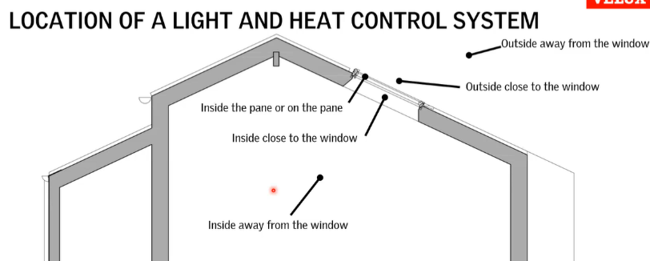An actual dilemma
  + Placement of window blind
    - Inside (Blind), Outside (Shutter)
    - Inside the pane / on the pane
    - Inside room not on the window
    - Outside the building
  + Light (Reason for placement)
    - Heat = Visible light, near-infrared light.
      * You can block infrared light (but not visible if you are not covering window)
      * Ability control heat is usually done outside (redirect)
      * If already penetrated it is indirect heating → heated material that conveys heating into room.
  + Current Products (and fun ideas)
    - Rolling trends between products – VELUX does not sell them all
    - Different trends based on geolocation.
    - See slide from 2nd meeting. (Most of them are probably bad ideas)
    - Products are made to last 25 years, only 1% must fail this.
  + Product Installation
    - Should be able to buy in BAUHAUS and install by themselves
    - Cannot be electricity heavy (no need to be certified engineer / installer)
  + How innovative can we be?
    - Roof window or flat roof window
    - Must interact with light/heat coming through the window.
  + Heat Sources (Mads)
    - What does the filter contain?
      * On the glass (depending on glazing) … see min. 00:57:45 – 01:01:30
      * Control heating outside.

# Appendix - A2

